📘 Agile Model – Documentation

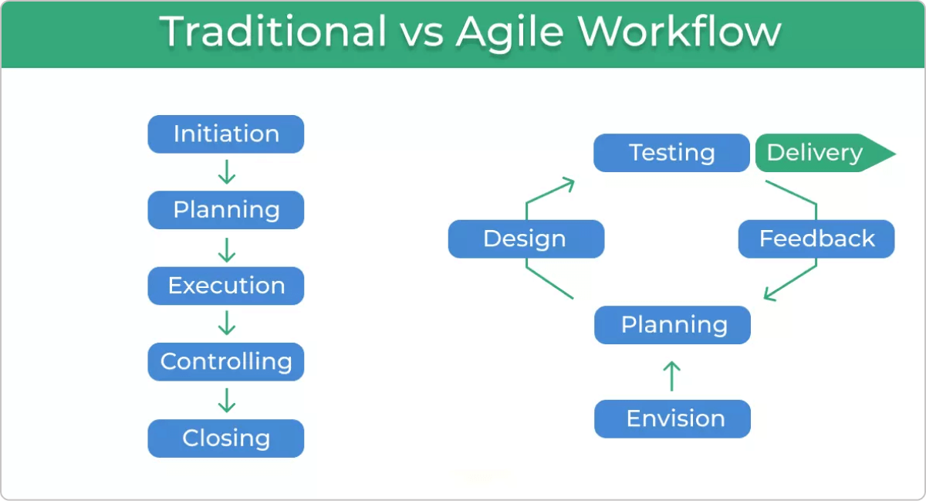
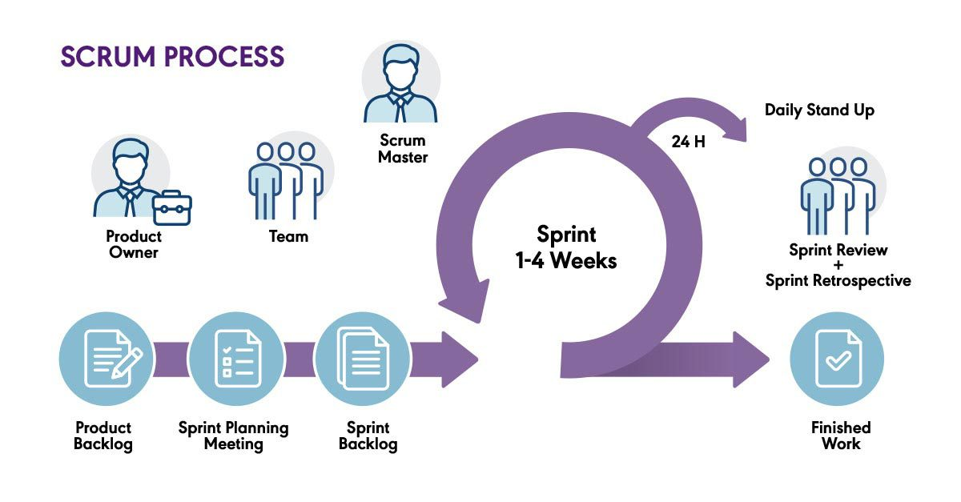
1. Introduction to Agile Model
The Agile model is a modern software development methodology that focuses on flexibility, customer collaboration, and rapid delivery. Instead of developing everything at once, Agile breaks work into small, manageable iterations called sprints. Each sprint produces a working product increment.
Agile adapts to changes quickly, making it ideal for projects with evolving or unclear requirements.
2. Key Principles of Agile
Agile is based on the Agile Manifesto, which emphasizes:
- Individuals and interactions over processes and tools
- Working software over comprehensive documentation
- Customer collaboration over contract negotiation
- Responding to change over following a fixed plan
These principles encourage flexibility, early delivery, and continuous improvement.
3. Agile Process – Step-by-Step

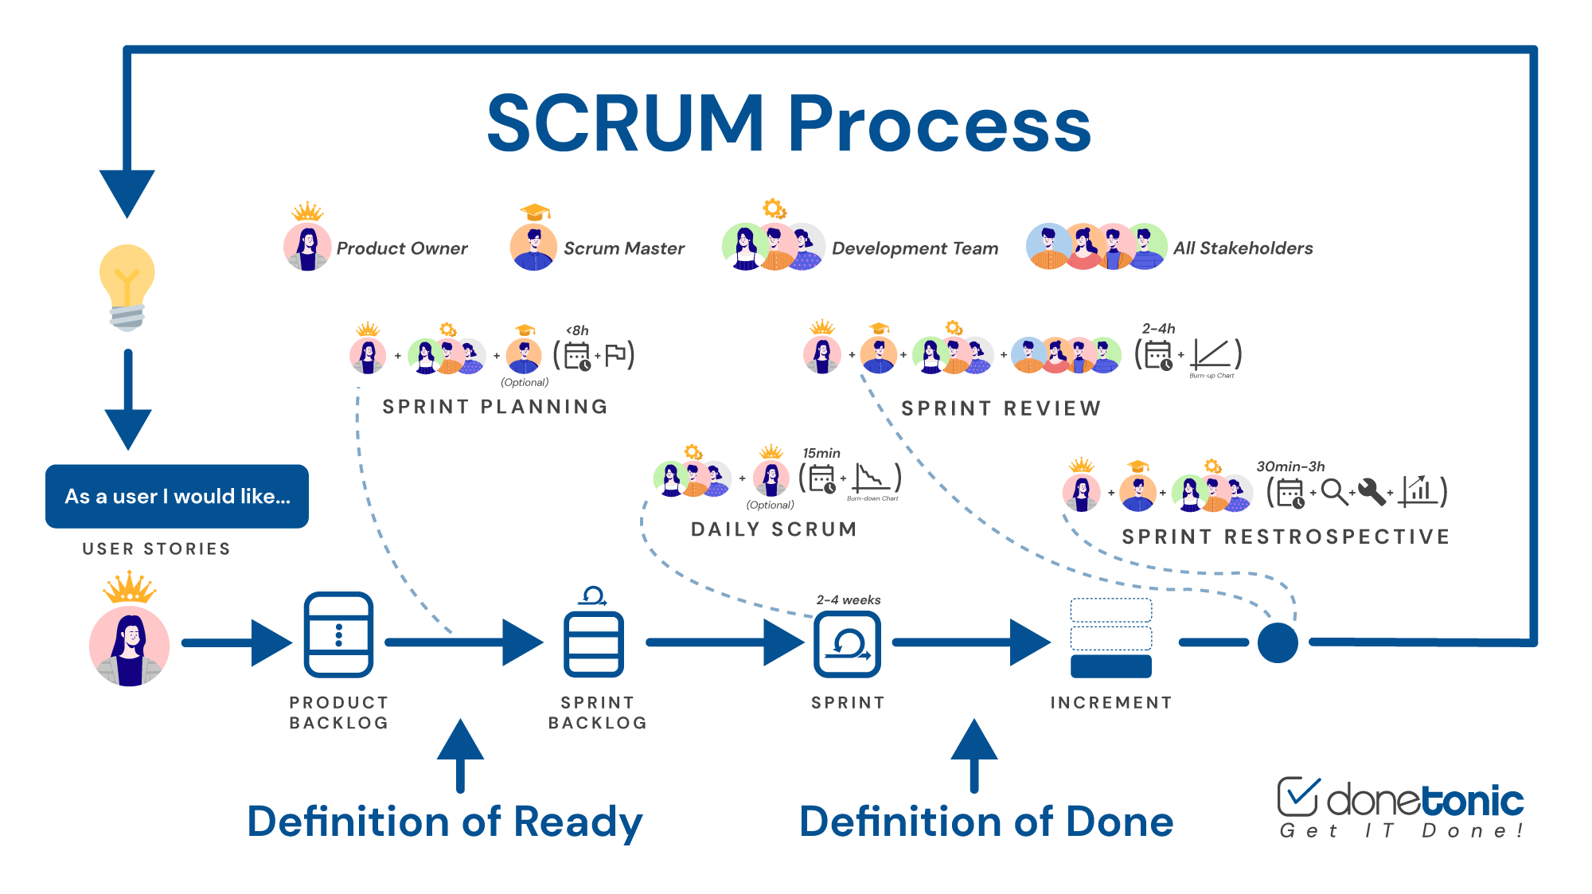

Step 1: Requirement Gathering (User Stories)
- Requirements are collected in the form of user stories.
- Instead of detailed documents, short descriptions are used.
- All stories go into the Product Backlog.
Example:
“As a user, I want to sign up using email so I can access my account.”
Step 2: Sprint Planning
- The team selects a set of stories to complete in a 1–4 week sprint.
- Tasks are estimated using story points or hours.
- A Sprint Backlog is created.
Step 3: Development & Coding
- Developers start working on selected tasks.
- Work is visualized using a Scrum Board (To-Do → In Progress → Done).
Step 4: Daily Scrum Meeting
- A short 15-minute meeting each day.
- Members answer:
  - What did I do yesterday?
  - What will I do today?
  - What blockers do I have?
Step 5: Testing
- Each completed feature is tested within the sprint.
- Continuous integration and testing are used to ensure stability.

Step 6: Sprint Review
- At the end of the sprint, the team demonstrates the working product to the customer or stakeholders.
- Feedback is collected for future improvements.
Step 7: Sprint Retrospective
- The team reflects on:
  - What went well
  - What didn’t
  - What can be improved next time
- Helps in continuous improvement of the development process.
4. Advantages of Agile
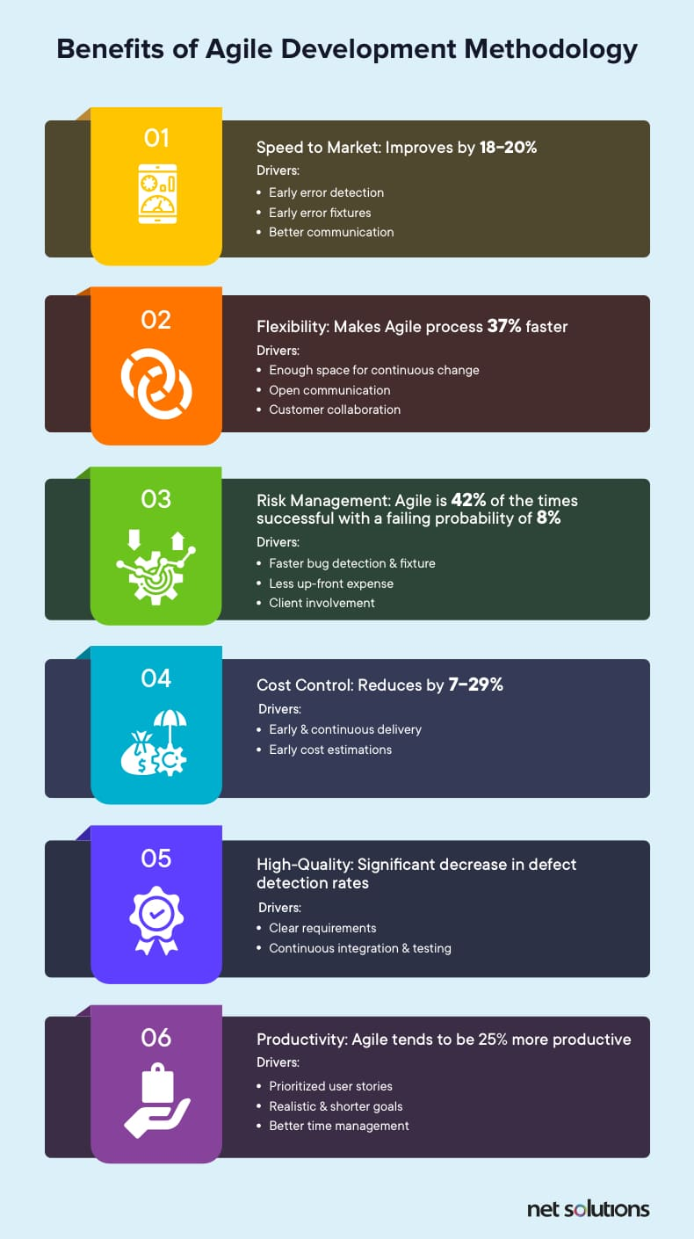

5. Disadvantages of Agile
- Requires experienced team members
- Harder to estimate exact cost and timeline
- Documentation may be less in early stages
- Needs continuous customer involvement
6. When to Use Agile
Agile is ideal when:
- Requirements may change or evolve
- Customer feedback is needed throughout
- Fast delivery is required
- The project is complex or innovative
7. Agile Models / Frameworks
Common frameworks under Agile:
- Scrum
- Kanban
- Extreme Programming (XP)
- Lean Software Development
- Crystal
8. Conclusion
The Agile model is a powerful, flexible, and customer-focused approach to software development. Through iterative cycles, continuous feedback, and rapid delivery, Agile helps build high-quality products while adapting to changes efficiently.

